# Assignment document

Contents

Assignment document 1

1. Prerequisites 2

2. Introduction to infrastructure/msa source code: 2

3. Setup infrastructure with Terraform: 4

4. Setup Jenkins pipeline for CI/CD 7

5. Setup ArgoCD 17

6 Setup Argo image updater 22

7 Using Grafana and Prometheus with EKS 23

# Prerequisites

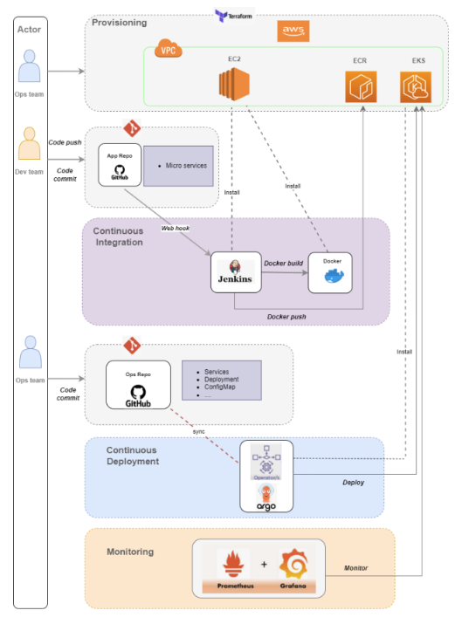

**Installation required to run the source code:**

1. Terraform**: Download and install from [terraform.io](https://www.terraform.io/downloads.html).

2. AWS CLI**: Download and install from [AWS CLI official docs](https://docs.aws.amazon.com/cli/latest/userguide/getting-started-install.html).

3. AWS Account**: You need an AWS account with permissions to create EKS, ECR, IAM, and VPC resources.

4. Configure AWS CLI**: You must configure your AWS credentials on your machine (see below).

# Introduction to infrastructure/msa source code:

* 1. **Infrastructure source code:**

Clone the repository on <https://github.com/cuonghongNT/sd0188_msa>

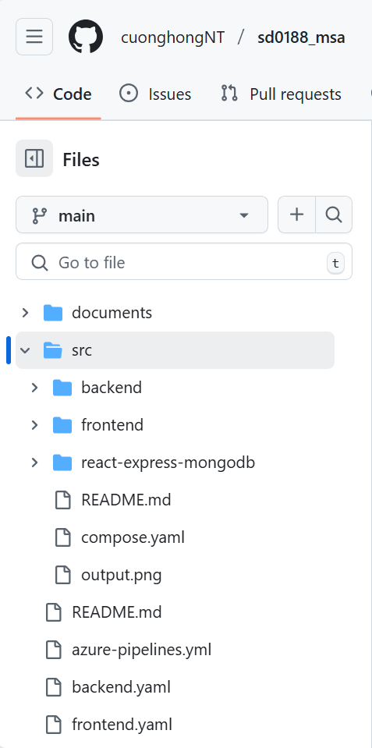

**The folders will contain these files and folder:**

* Folder backend, backend source code and docker file
* Folder frontend, frontend source code and docker file
* Folder mongodb, mongodb source code and docker file
* File azure-pipelines.yml contain pipeline for azure to deploy “CI part in CI/CD”
  1. **MSA source code:**

Clone the repository on [https://github.com/[cuonghongNT/sd0188_aws_infrastructure](https://github.com/cuonghongNT/sd0188_aws_infrastructure)](https://github.com/cuonghongNT/sd0188_azure_infrastructure)

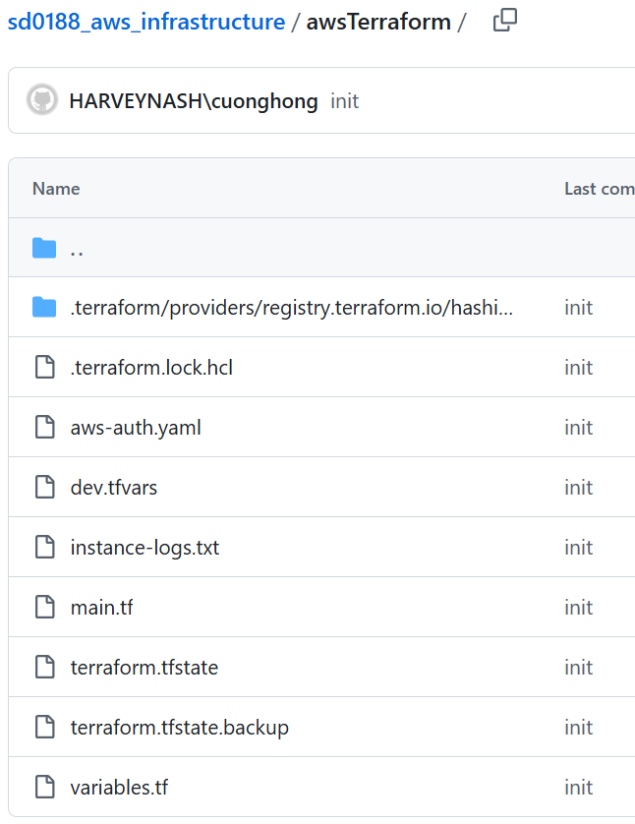

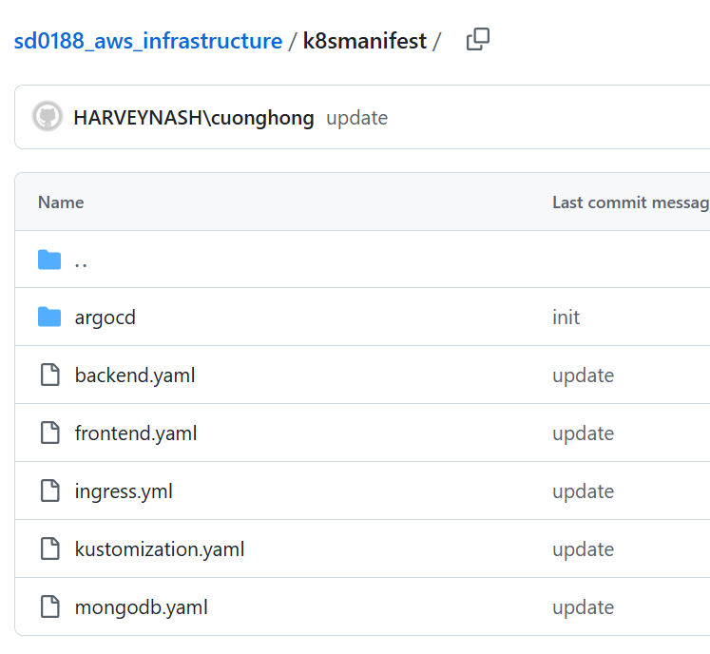

# Setup infrastructure with Terraform:

* 1. **Configure AWS CLI**

Open PowerShell and run:

aws configure

Enter your AWS Access Key ID, Secret Access Key, default region (e.g., `us-west-2`), and output format (`json`).

To verify your credentials, run:

aws sts get-caller-identity

You should see your AWS account details if configured correctly.

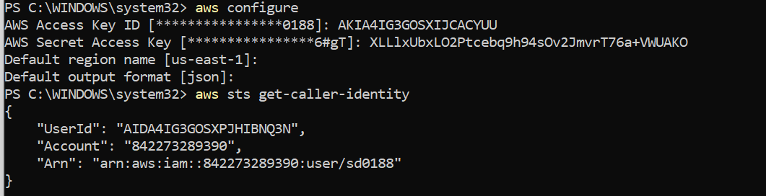

* 1. **Initialize Terraform**

Run terraform init to initialize the Terraform deployment.

Command

terraform init -upgrade

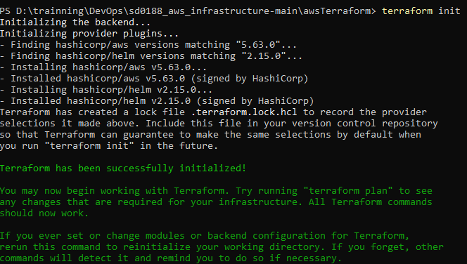

* 1. **Create a Terraform execution plan**

Run terraform plan to create an execution plan.

Command

terraform plan -out main.tfplan

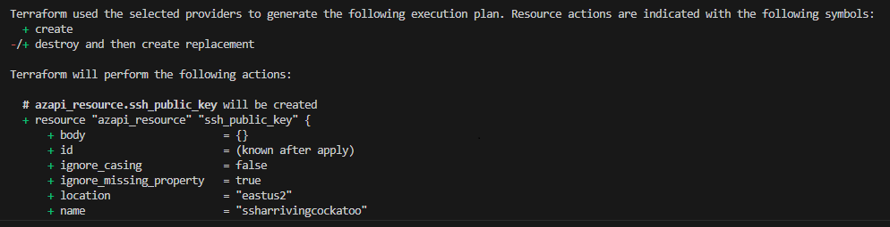

* 1. **Apply a Terraform execution plan**

Run Terraform apply to apply the execution plan to your cloud infrastructure.

Command

terraform apply -var-file="dev.tfvars" -auto-approve

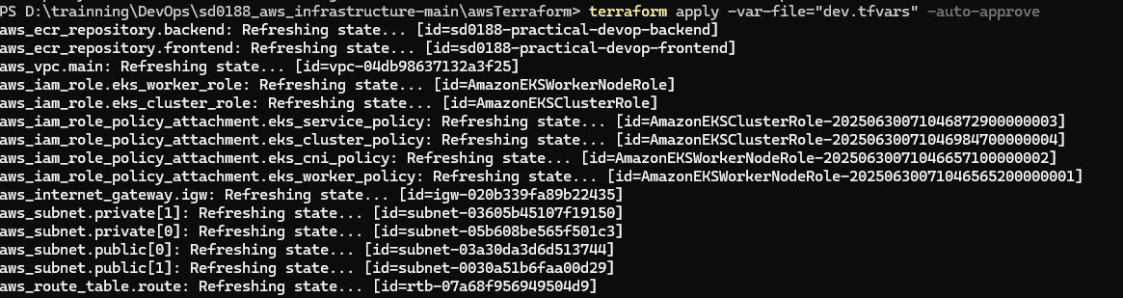

* 1. **Verify the results:**

**. VPC**

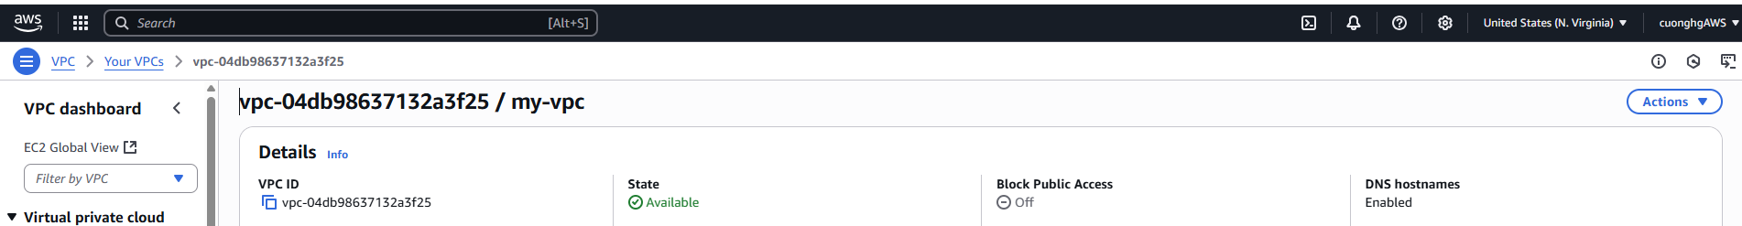

**. ECR**

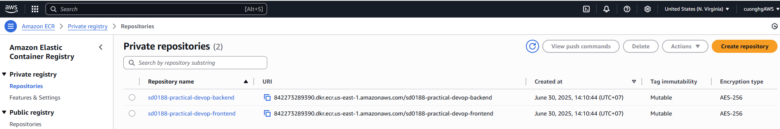

**. EKS**

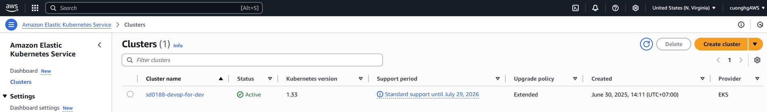

# Setup Jenkins pipeline for CI/CD

* 1. **Check Jenkins version:**

apt list --installed | grep jenkins

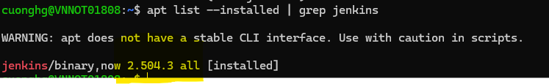

If the command is not found, Jenkins might not be installed, or the system’s PATH may not include Jenkins.

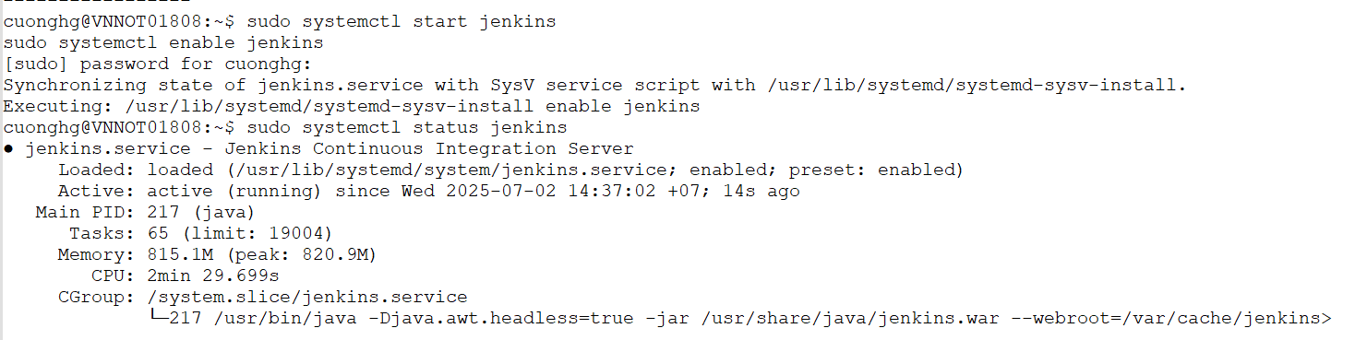

* 1. **Access Jenkins in a Browser:**
* At the first time:

sudo cat /var/lib/jenkins/secrets/initialAdminPassword

for get password with default username is: **admin**

* After login:

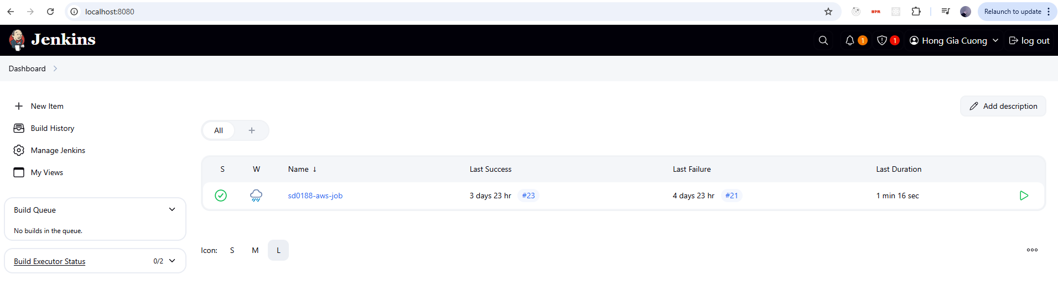

We should install some plugins:

1. Go to ***Manage Jenkins > Manage Plugins*** and follow bellow step:

* **Pipeline Plugin**: Provides Jenkins support for building Docker images and running Docker containers in pipelines.
* Go to the **Available** tab.
* Search for **Docker Pipeline**.
* Check the box next to **Docker Pipeline**.
* Click **Install**

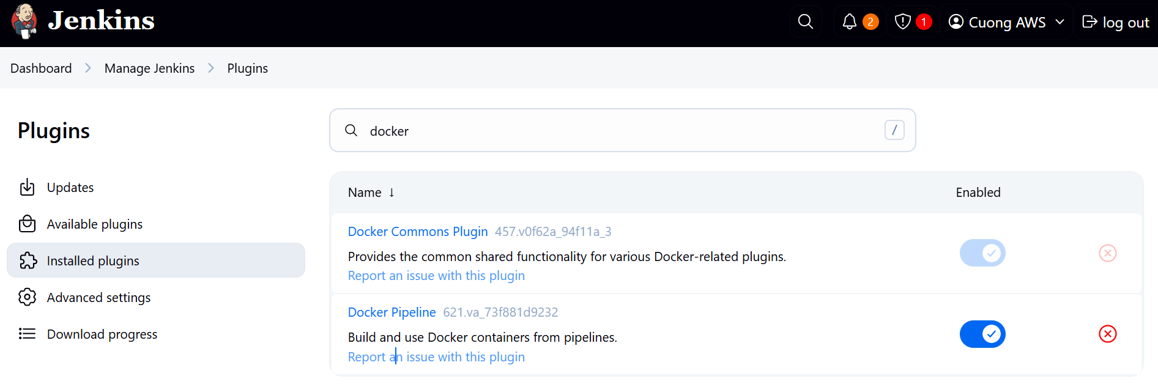

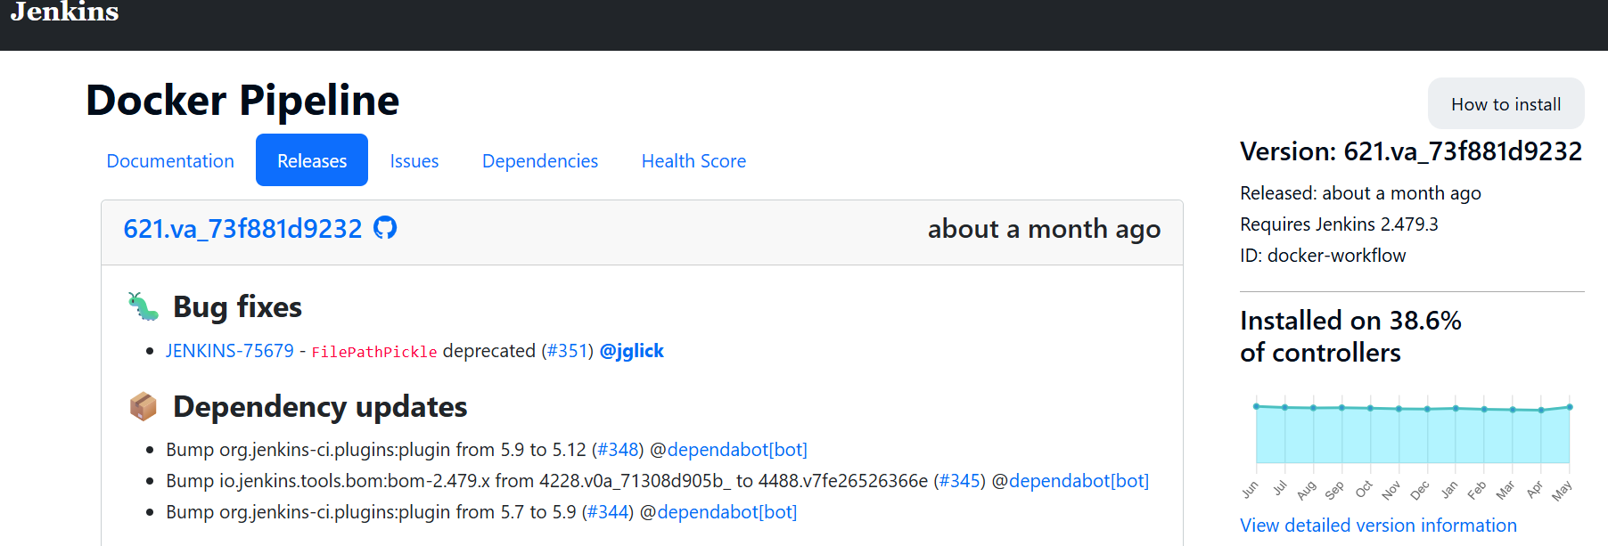

1. ***Pipeline Utility Steps Plugin***: Provides utility steps for Jenkins pipelines, such as reading and writing files.

* Go to the **Available** tab.
* Search for **Pipeline Utility Steps**.
* Check the box next to **Pipeline Utility Steps**.
* Click **Install**

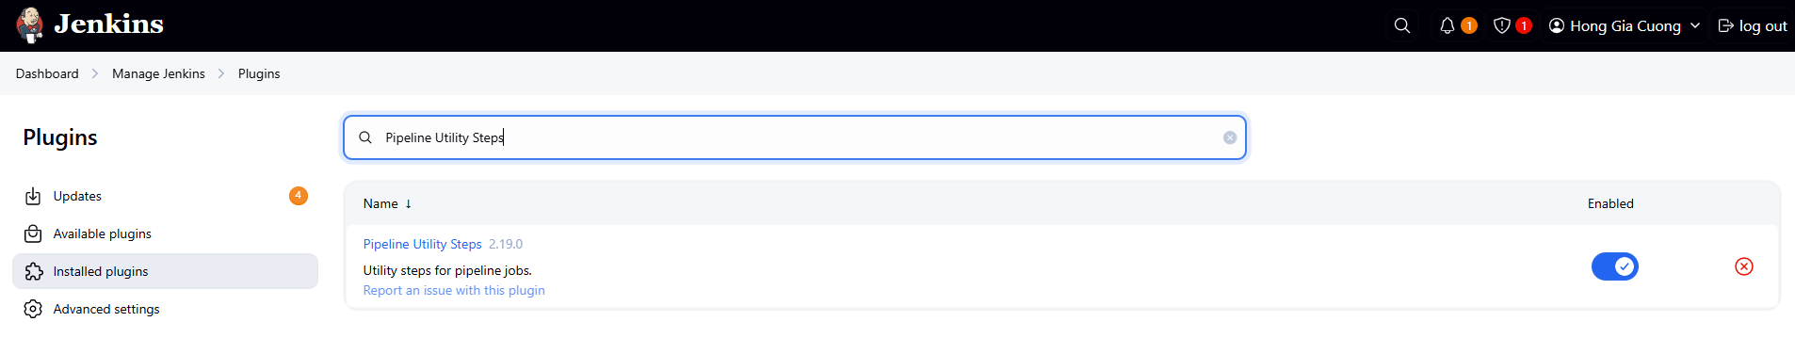

1. ***Kubernetes Plugin***: Provides integration with Kubernetes for Jenkins.

* Go to the **Available** tab.
* Search for **Kubernetes**.
* Check the box next to **Kubernetes**.
* Click **Install**

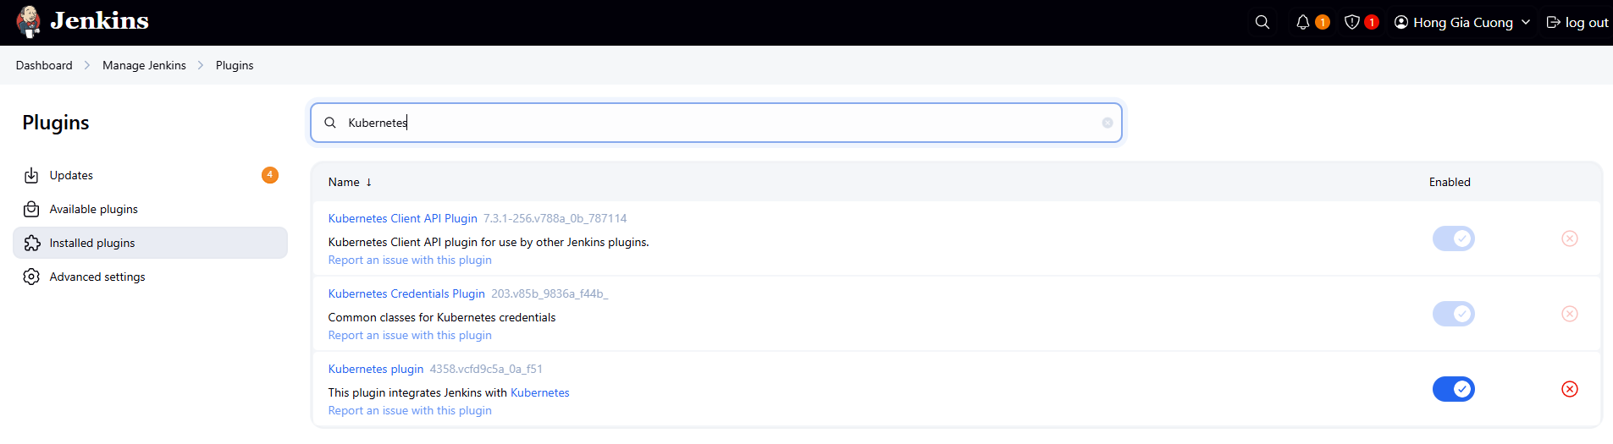

1. ***Configure Amazon EC2*** ***Plugin***

* Go to **Manage Jenkins > Configure System**.
* Scroll down to the **Cloud** section
* Click **Add a new cloud**.

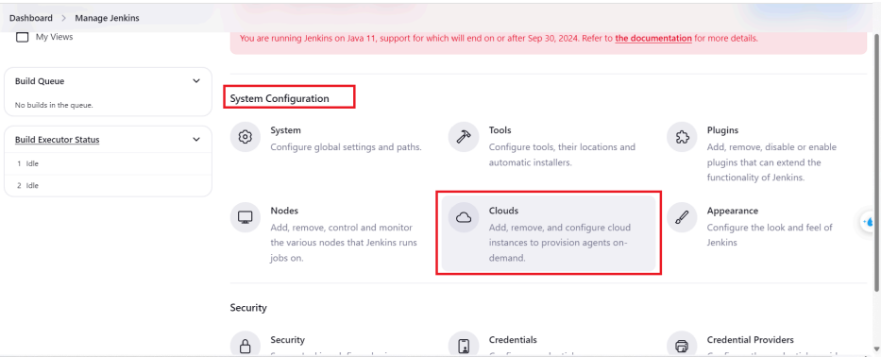

* Select **Amazon EC2** from the drop-down menu

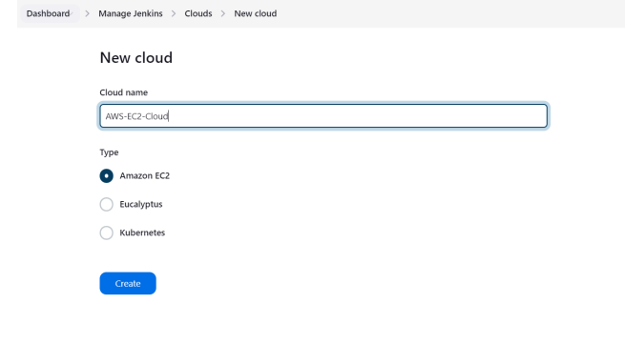

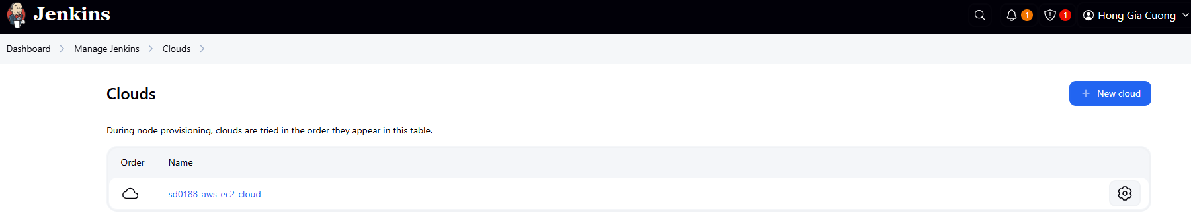

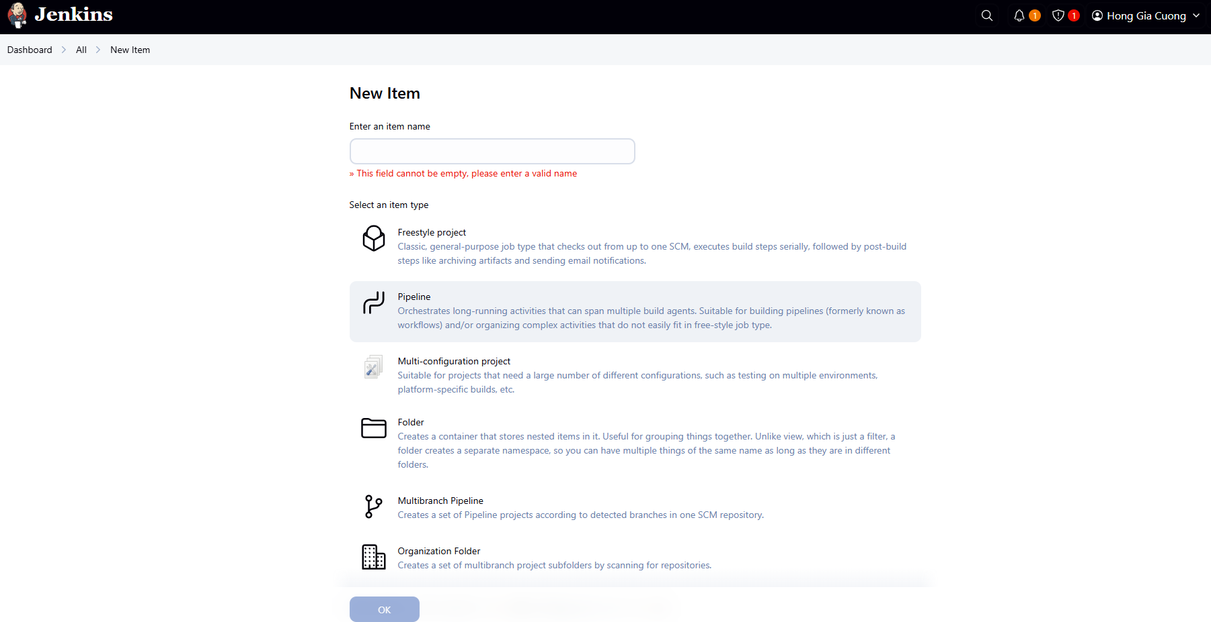

1. **Configure EC2 Settings**

Fill in the EC2 cloud configuration settings:

. **AWS Credentials**:

* Click **Add** to enter your AWS credentials and we need to provide your AWS Access Key ID and Secret Access Key

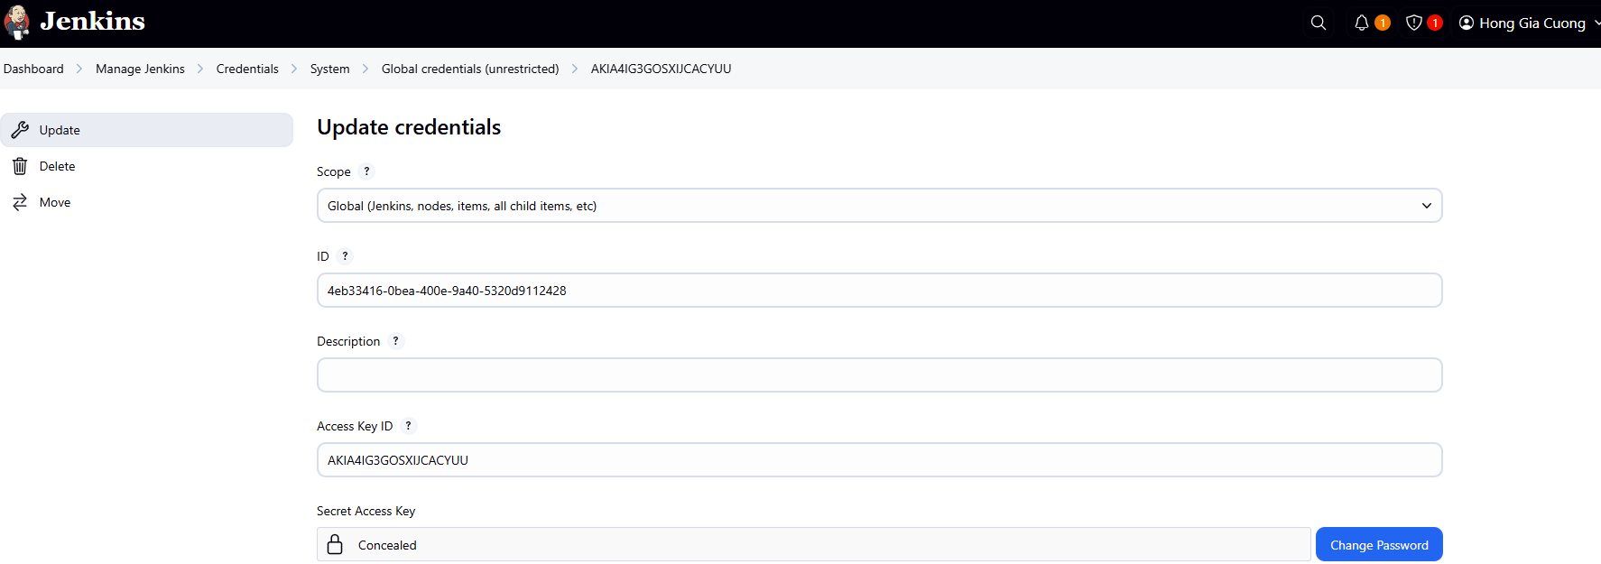

. **Github Credentials**:

Generate a New SSH Key

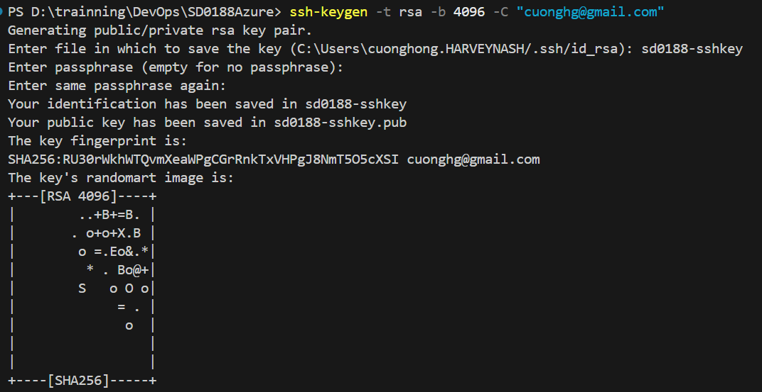

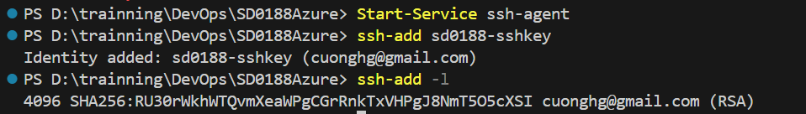

Now, go to GitHub SSH settings and click "New SSH key". Paste your key into the "Key" field, give it a title, and click "Add SSH key".

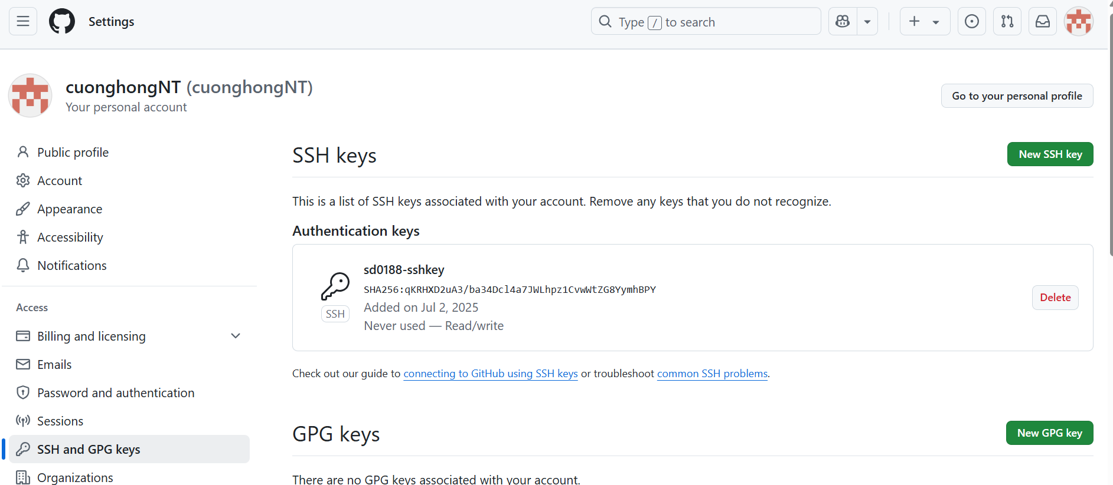

**. Test SSH Connection**

ssh -T git@github.com

**.** Back to UI. Fill in some fields required for build

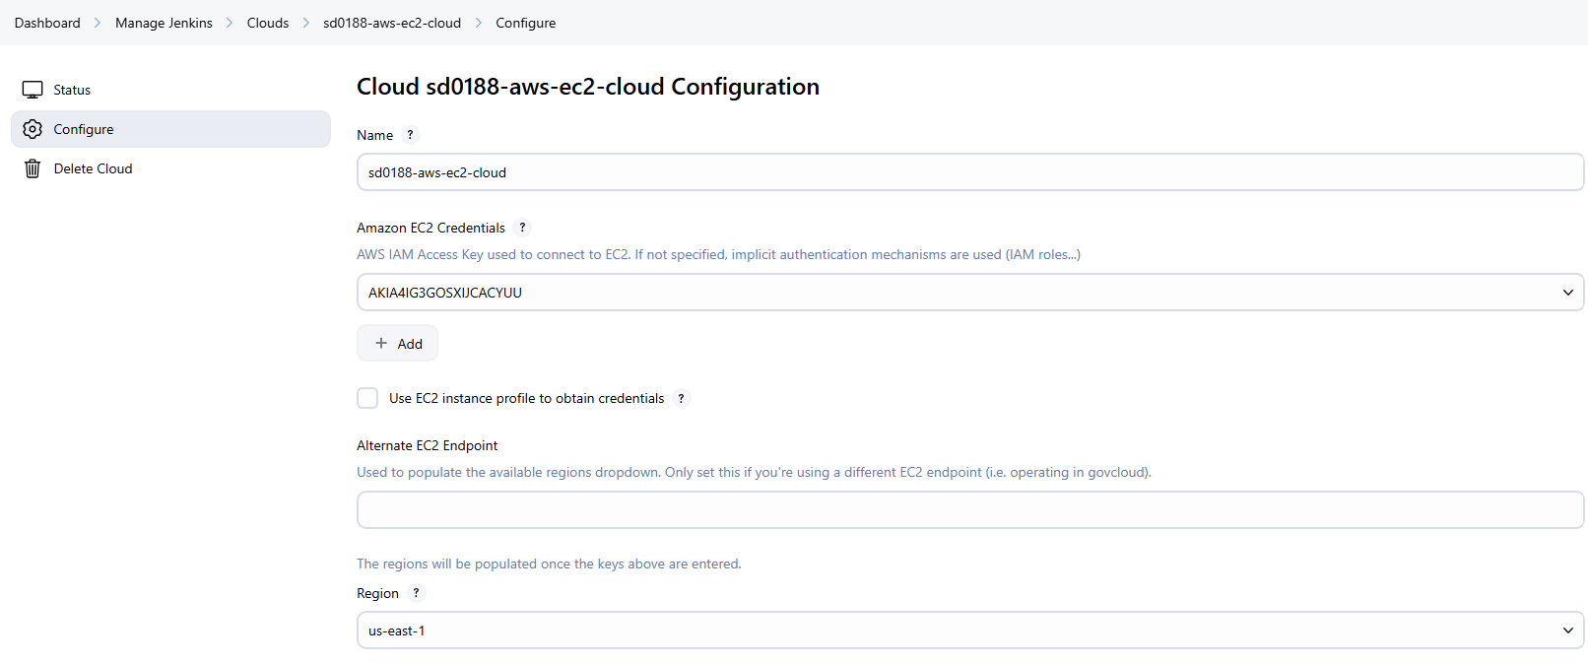

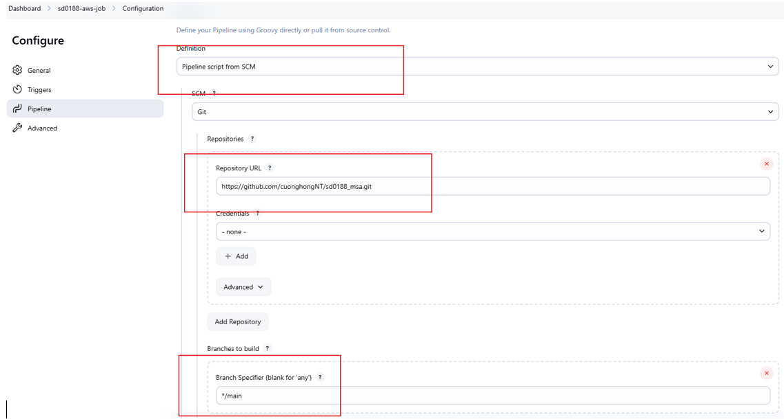

. Click Save

. Update Jeninsfile.yml:

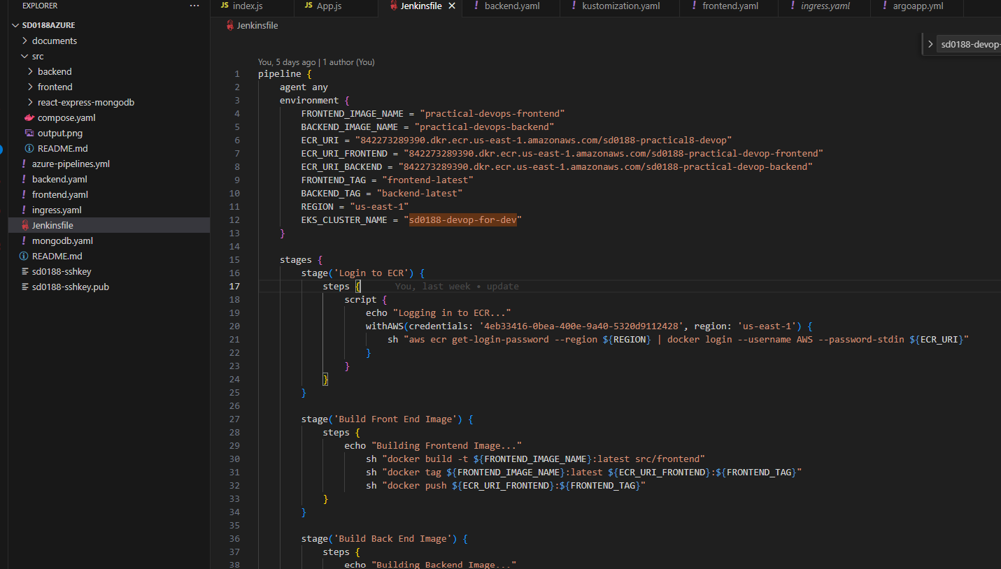

**.** Update to these files:

* kustomization.yaml:

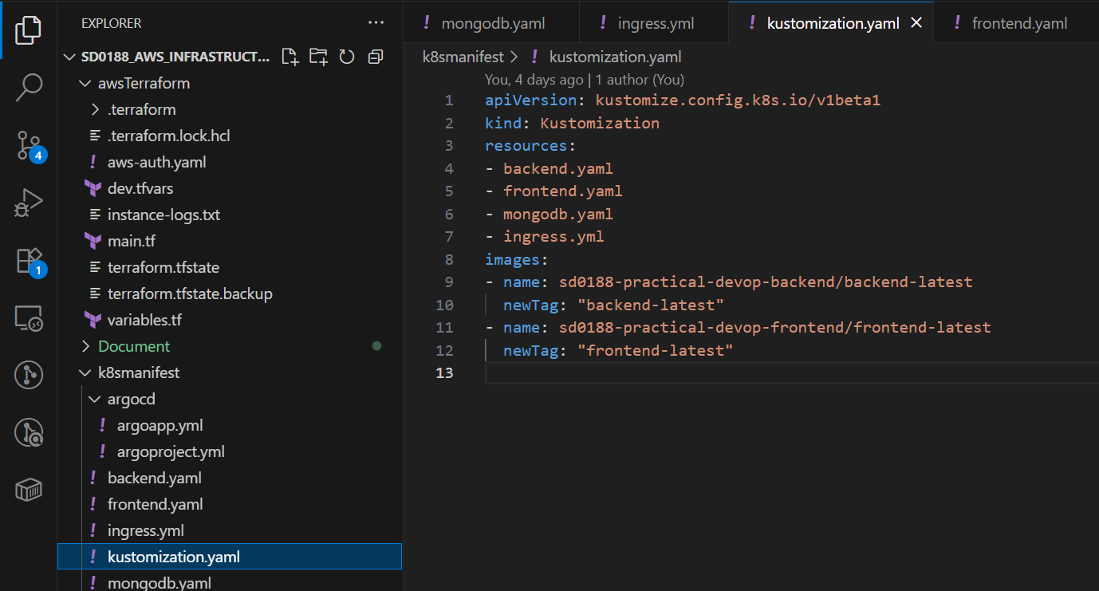

* backend.yaml:

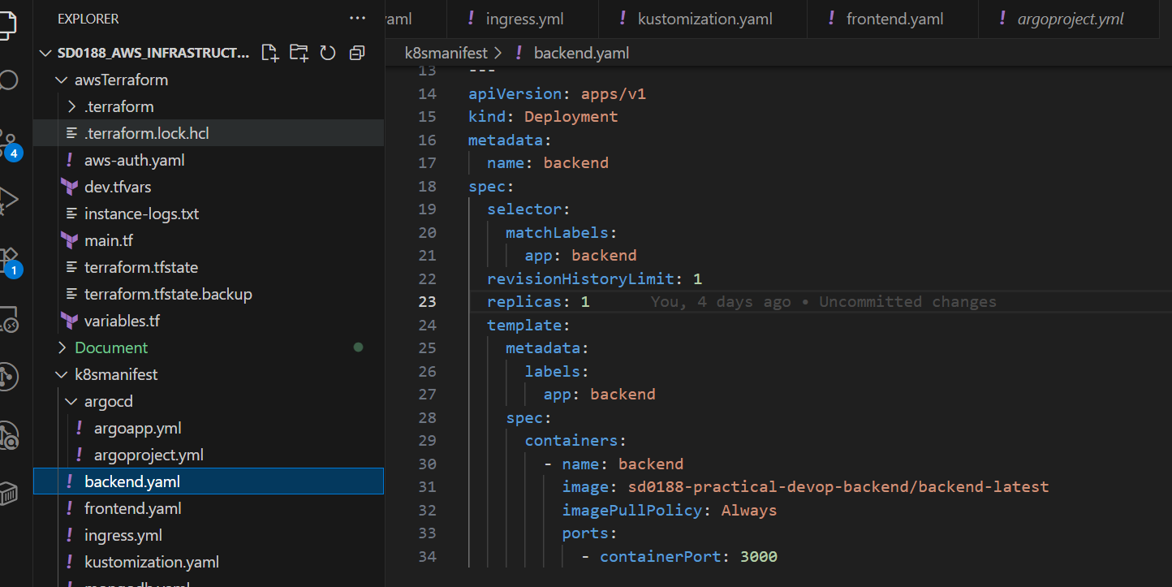

* frontend.yaml:

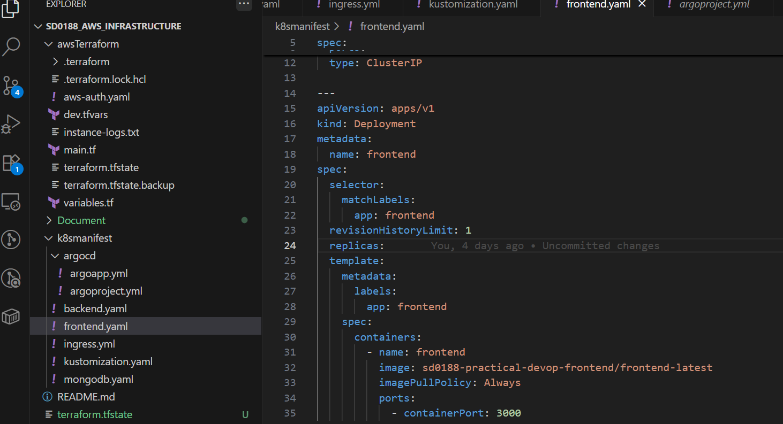

. And test build

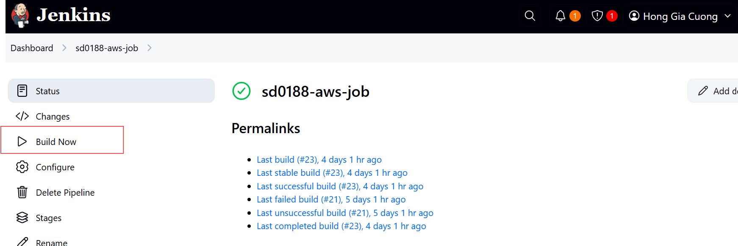

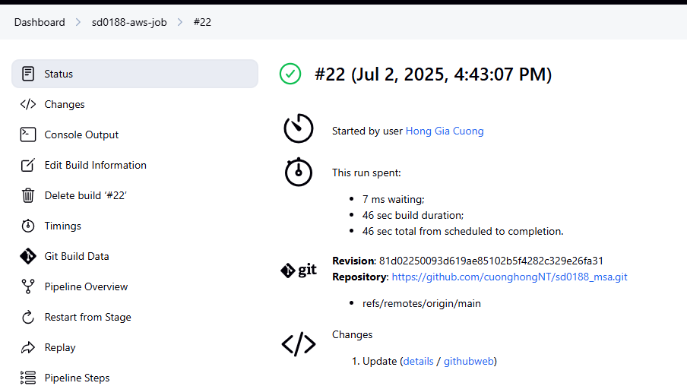

**.** Check at AWS ECR we can see 2 images have created successfully

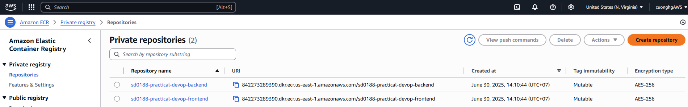

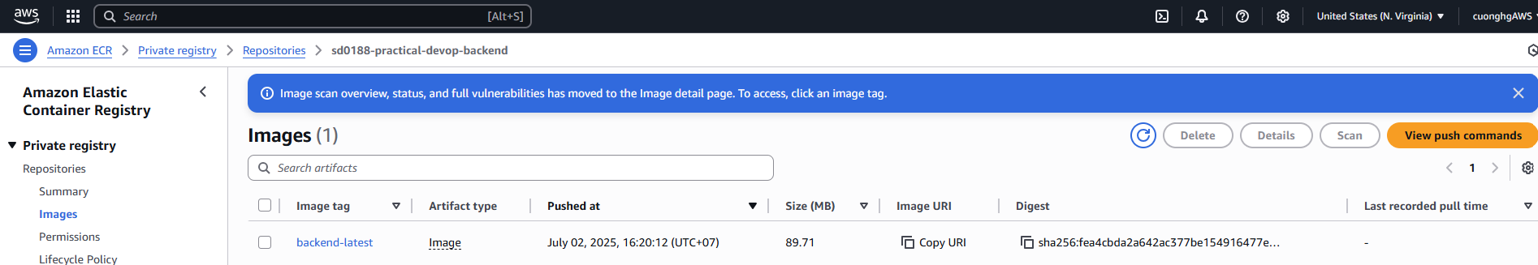

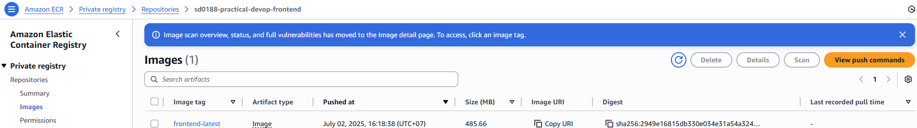

**. EKS:**

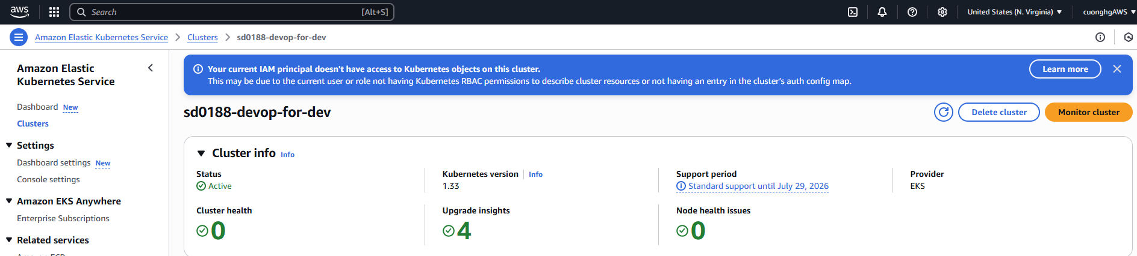

. After completing the setup, click on Deploy

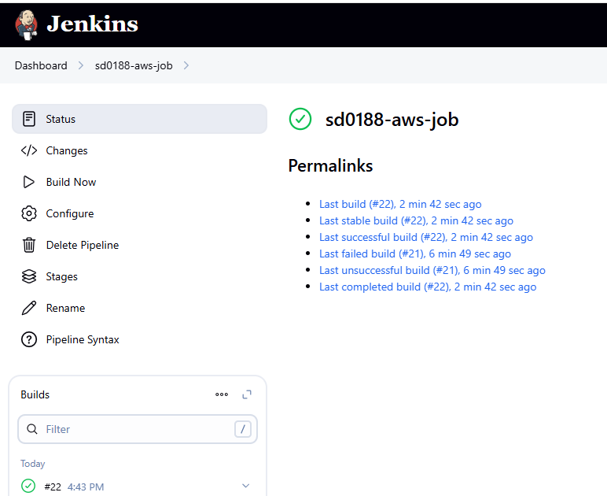

**. Check pods:**

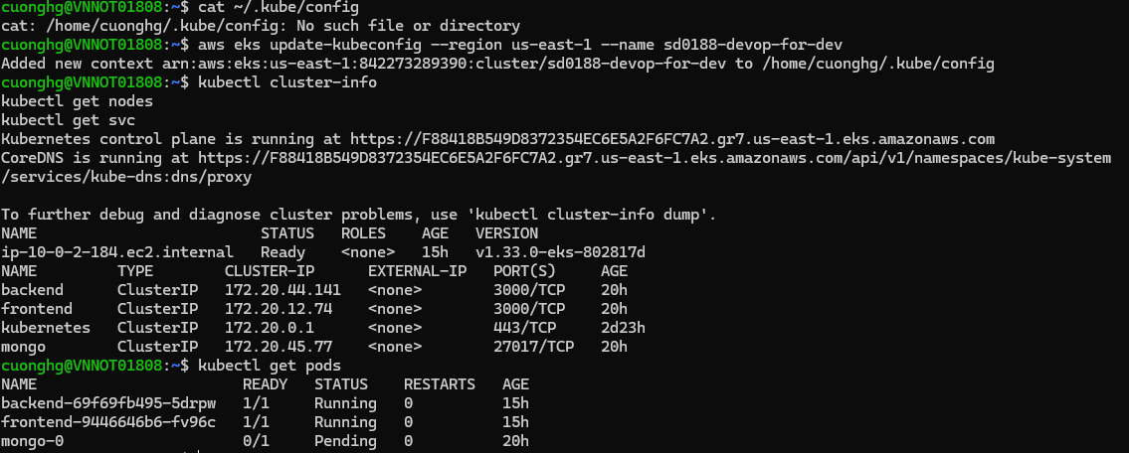

1. **Install NGINX ingress controller**

Command

kubectl apply -f <https://raw.githubusercontent.com/kubernetes/ingress-nginx/controller-v1.7.1/deploy/static/provider/cloud/deploy.yaml>

* 1. Getting the address

Command

kubectl get ingress -o wide



* 1. Access the address and verify result



# Setup ArgoCD

* 1. **Create namespace**

Command

kubectl create namespace argocd

* 1. **Setup ArgoCD:**

Command

kubectl apply -n argocd -f <https://raw.githubusercontent.com/argoproj/argo-cd/stable/manifests/install.yaml>

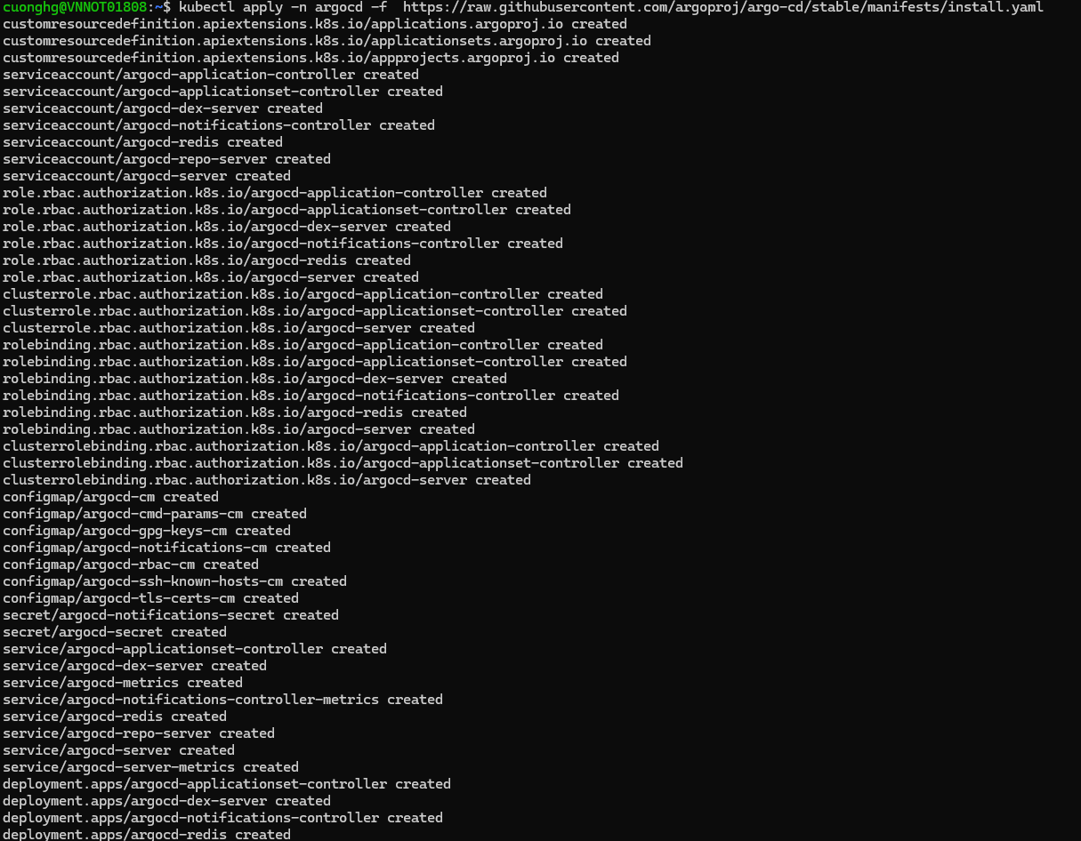

* 1. **Get account password:**

Command

kubectl -n argocd get secret argocd-initial-admin-secret -o jsonpath=”{.data.password}”



* 1. **Decode it and get the value before root with the command on linux wsl:**

Command

echo YnJDQ1p4ZVQ0ZXlYZkUwZQ== | base64 --decode



* 1. **Port forward it and access it local with the command:**

Command

kubectl port-forward svc/argocd-server -n argocd 9090:443



Access it with:

username: admin

password: the decoded secret above (brCCZxeT4eyXfE0e)

* 1. **Verify result:**

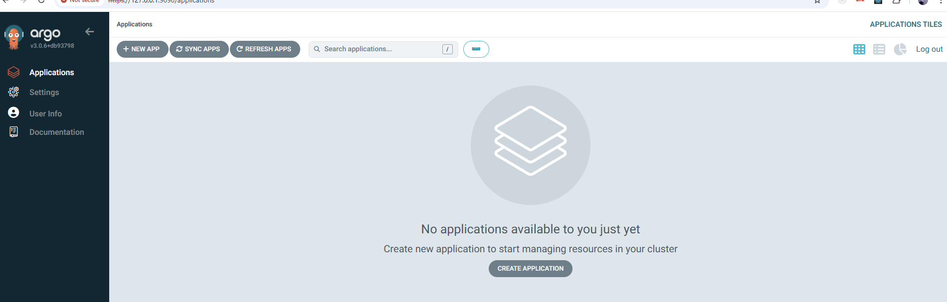

* 1. **Setup project**

Command

kubectl apply -f argoproject.yml



* 1. **Verify result:**

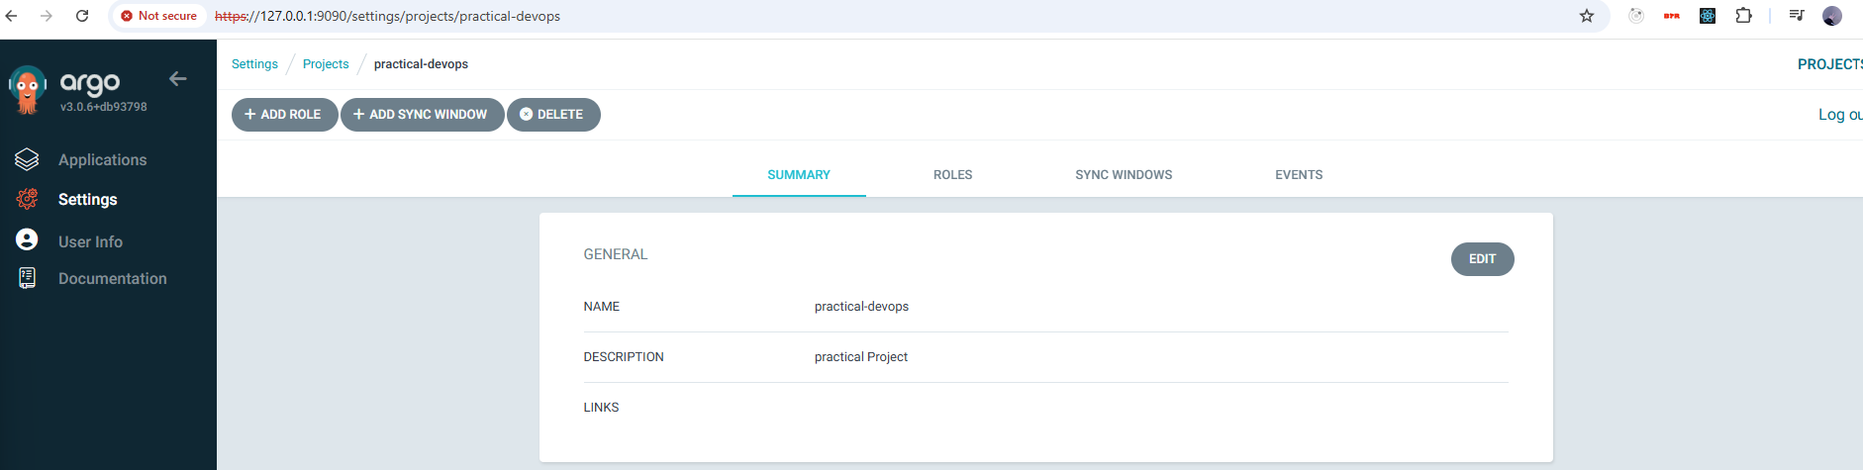

* 1. **Setup app:**

Command

kubectl apply -f argoapp.yml



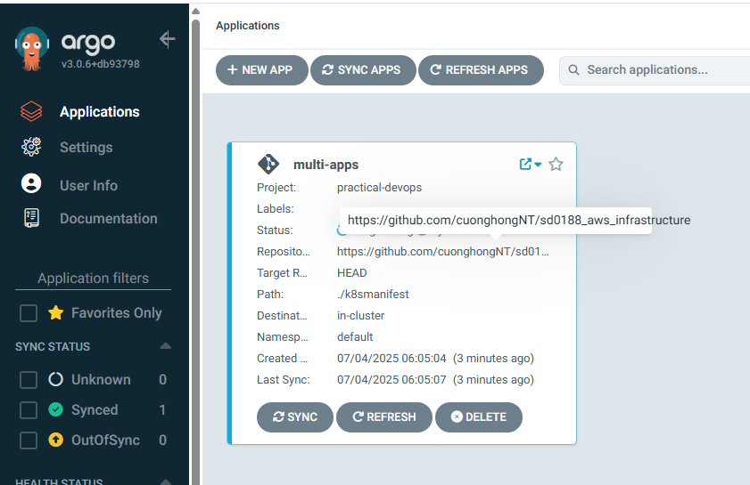

* 1. **Verify result:**

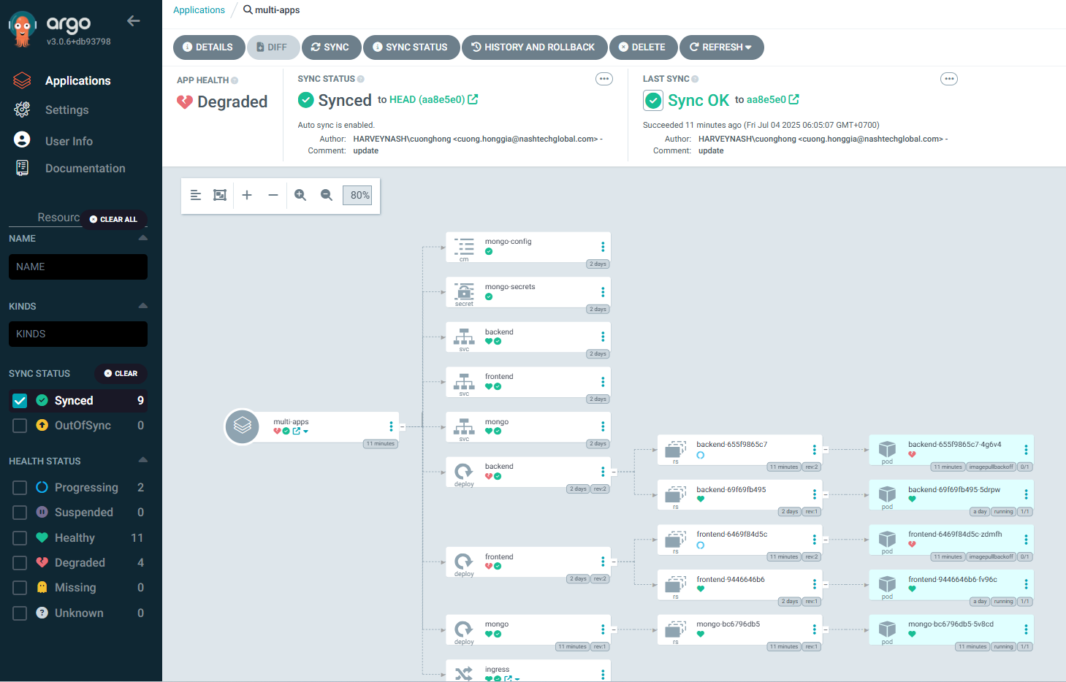

* 1. **Test your ArgoCD:**

Look we got 3 frontend pods and 2 pods Mongodb so let’s fix that:

* + 1. **Frontend:**

Change replicas value from 3 to 1

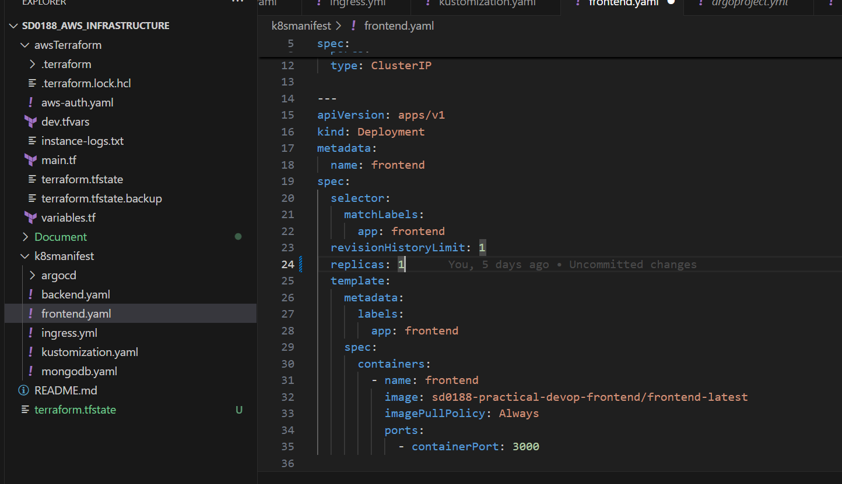

* + 1. **MongoDB:**

Change replicas value from 2 to 1

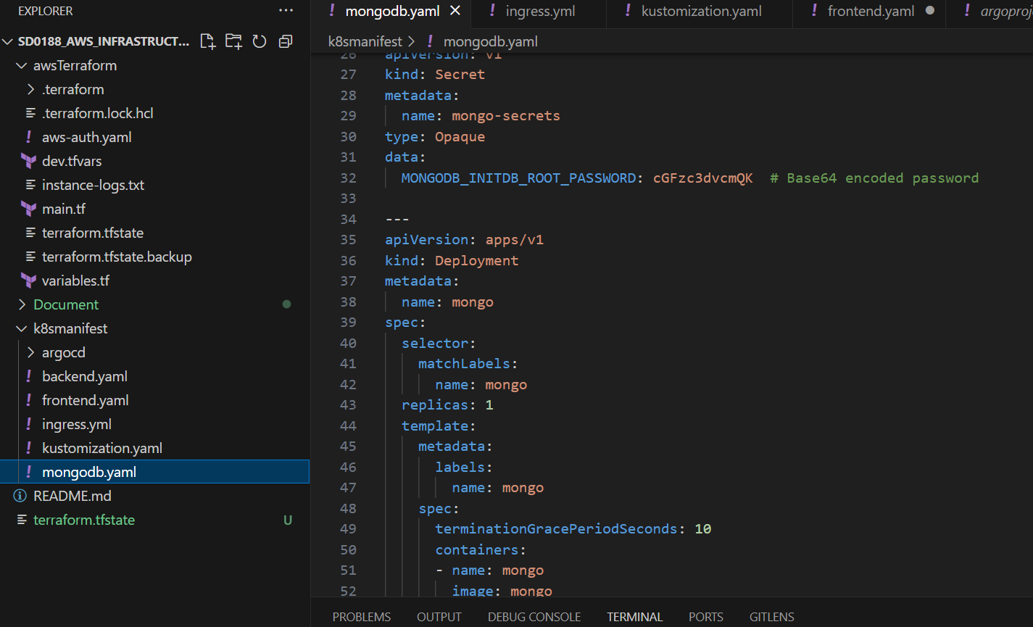

* + 1. **Verify the result you will see Mongodb, frontend pods will be in terminating status:**

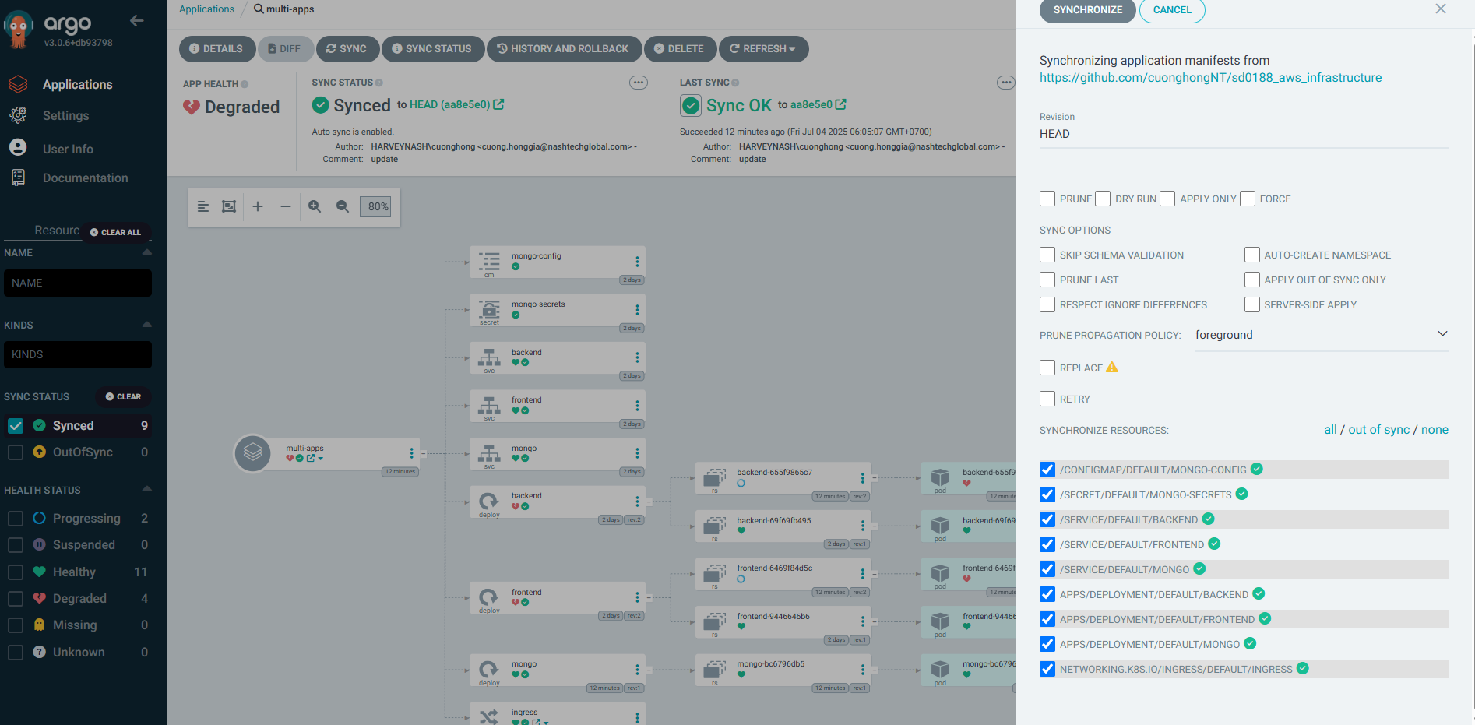

# Setup Argo image updater

* 1. **Setup Argo image updater with command:**

Command

kubectl apply -n argocd -f <https://raw.githubusercontent.com/argoproj-labs/argocd-image-updater/stable/manifests/install.yaml>

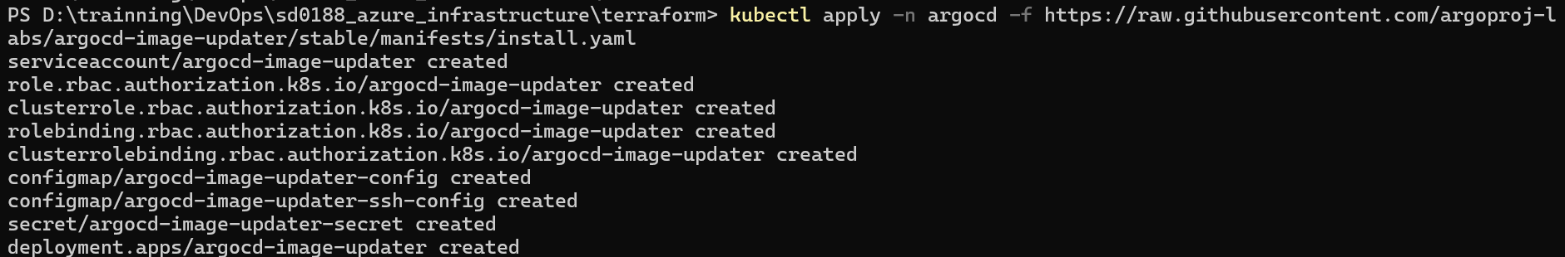

* 1. **Add data config for it to pull repo from ECR**

Command

kubectl edit configmaps --namespace argocd argocd-image-updater-config

Add below code to the boottom of the Configmaps file:

data:

log.level: debug

registries.conf: |

registries:

name: sd0188-devop-for-dev

prefix: 842273289390.dkr.ecr.us-east-1.amazonaws.com/sd0188-practical8-devop

api_url: https://842273289390.dkr.ecr.us-east-1.amazonaws.com/sd0188-practical8-devop

credentials: pullsecret:argocd/argocd-acr-secret

# Using Grafana and Prometheus with EKS

* 1. **Add its repository to our repository list and update it**

Command

helm repo add prometheus-community https://prometheus-community.github.io/helm-charts

helm repo update

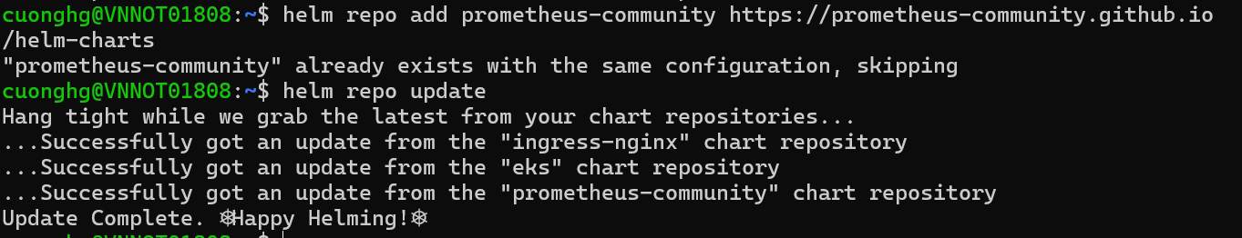

* 1. **Install the Helm chart into a namespace called monitoring, which will be created automatically.**

Command

helm install prometheus prometheus-community/kube-prometheus-stack --namespace monitoring --create-namespace



By default, all the monitoring options for Prometheus will be enabled. Let’s leave it this way for now.

* 1. **Create a port forward to access the Prometheus query interface.**

Command

kubectl port-forward --namespace monitoring svc/prometheus-kube-prometheus-prometheus 9191



* 1. **Open http://localhost:9191 in your web browser and explore the UI to see the raw metrics inside Prometheus**

Command

kubectl port-forward --namespace monitoring svc/prometheus-grafana 8181:80



**You will need to stop the previous port forward command, or run this in another terminal if you would like to run them side by side.**

Open <http://localhost:8181> in your web browser.

The default username for Grafana is admin and the default password is prom-operator. You can change it in the Grafana UI later.

* 1. **Results:**

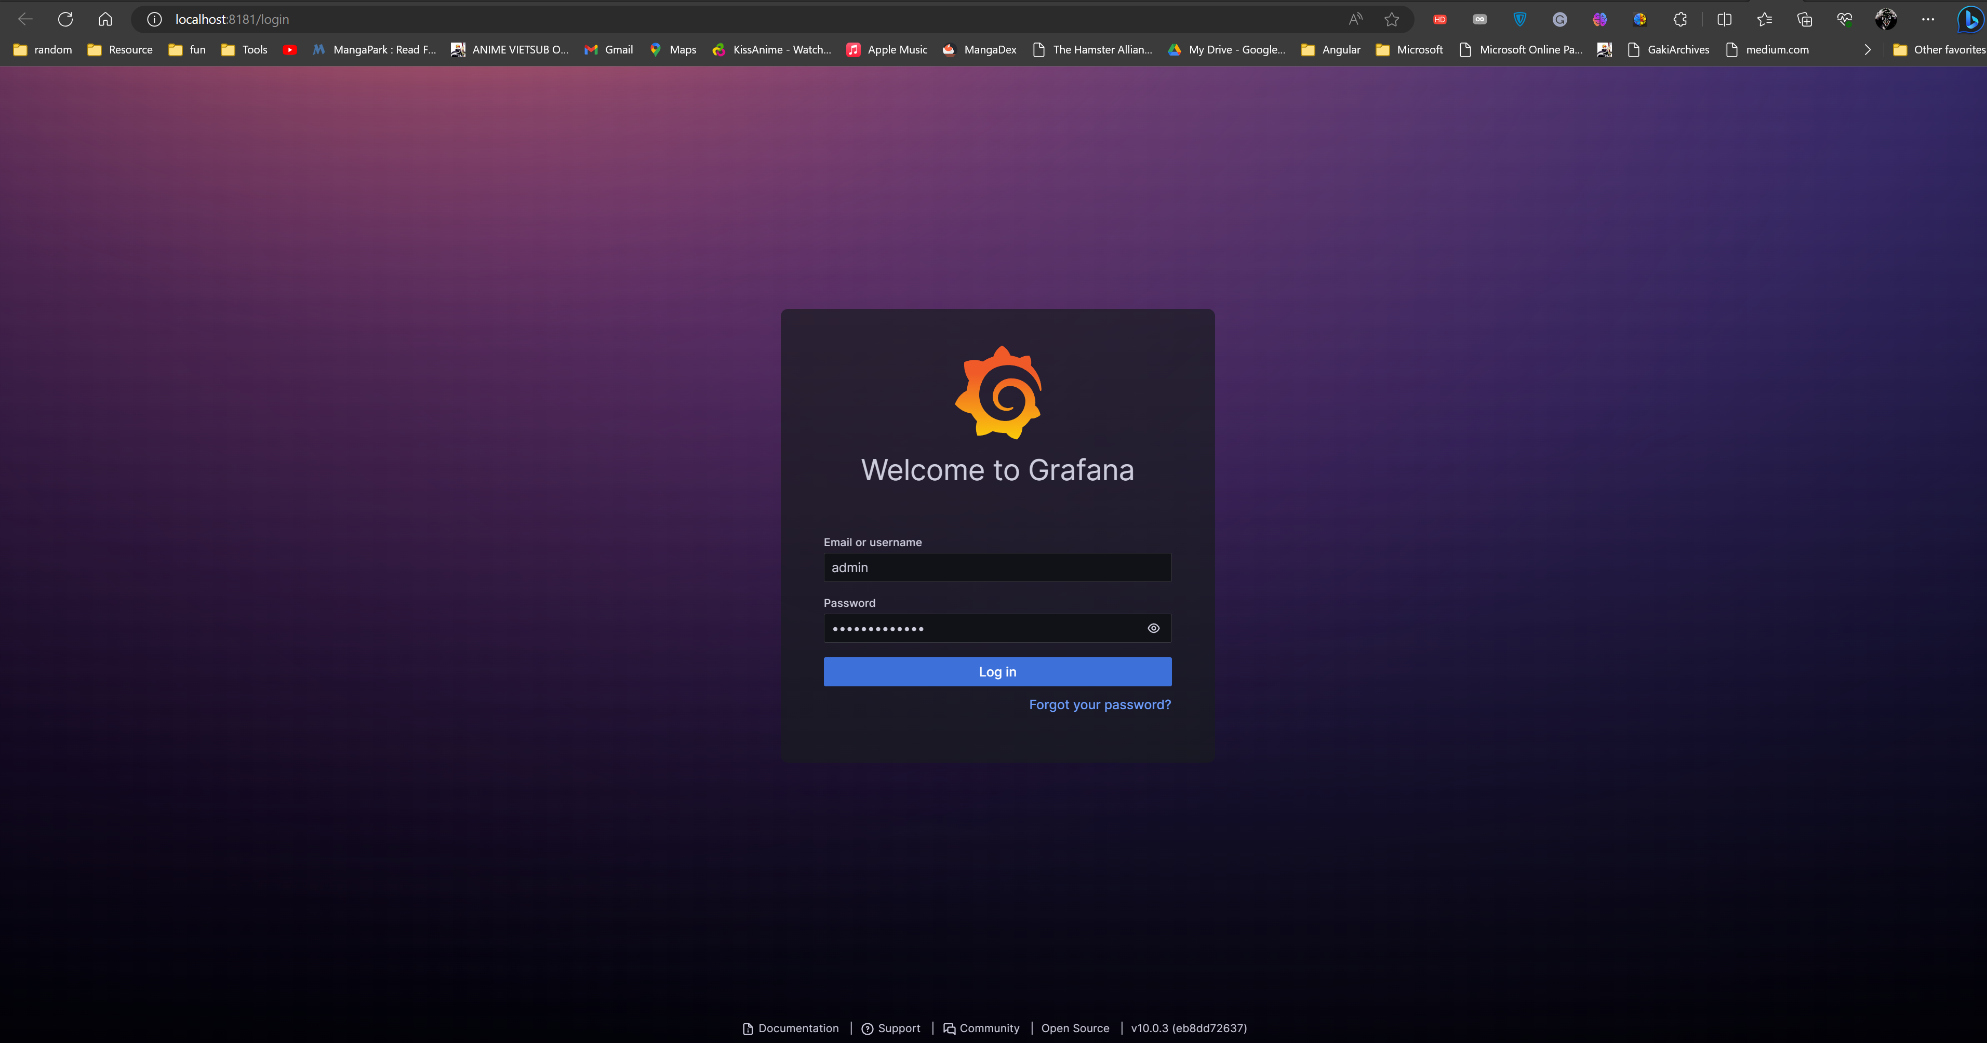

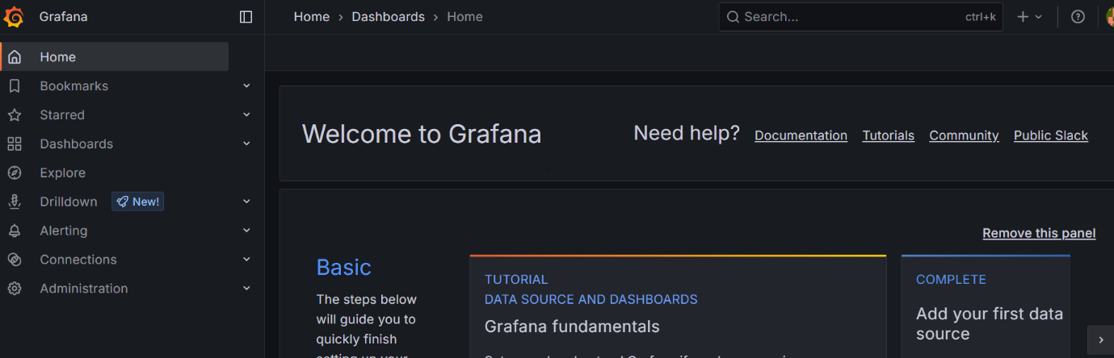

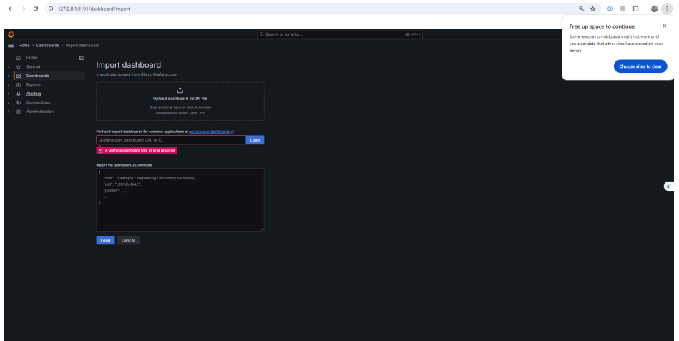

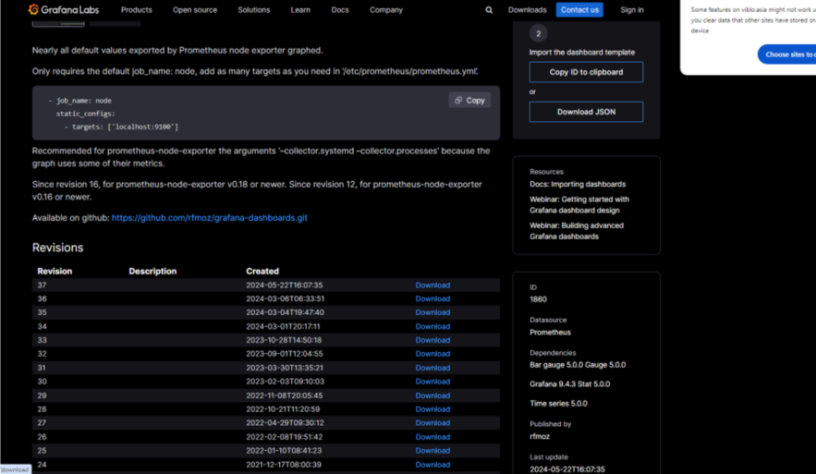

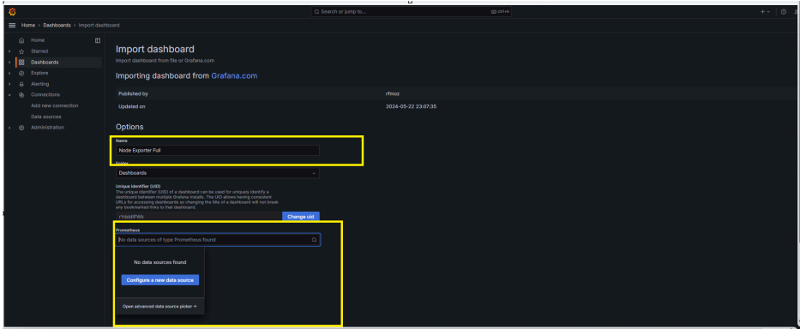

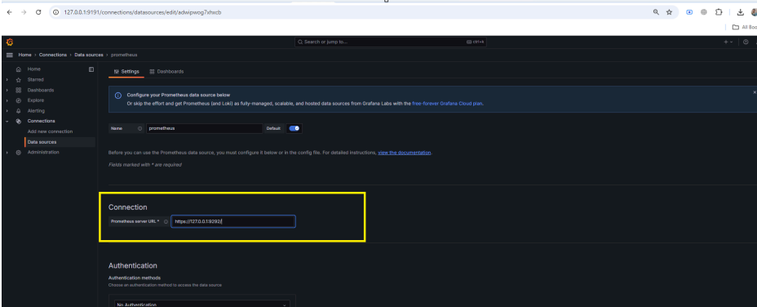

* 1. Verify the final result:

